**Goddard Labs not interpolated New Data**

Learning Regression Tree...

Elapsed time is 0.638690 seconds.

Training RMSE(W): 3.24, R2: 0.910, RMSE/peak: 0.0254, NRMSD: 3.57

Learning a cross validated tree...

Elapsed time is 5.739928 seconds.

Cross Validated Training RMSE(W): 6.40, R2: 0.647, RMSE/peak 0.0502, NRMSD: 7.06

Learning a Random Forest...

Elapsed time is 180.141582 seconds.

Random Forests Training RMSE(W): 3.50, R2: 0.894, RMSE/peak 0.0275, NRMSD: 3.86

Testing RMSE(W): 15.49, R2: 0.000, RMSE/peak: 0.1109, NRMSD: 16.13

Cross Validated Testing RMSE(W): 14.54, R2: 0.000, RMSE/peak 0.1040, NRMSD: 15.13

RF (Testing) RMSE(W): 13.43, R2: 0.000, RMSE/peak 0.0961, NRMSD: 13.98

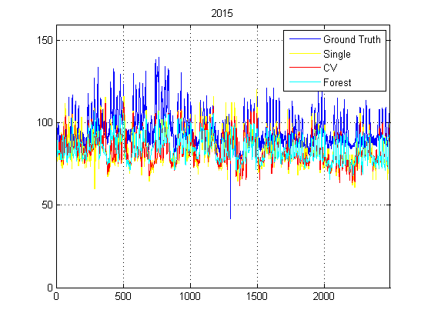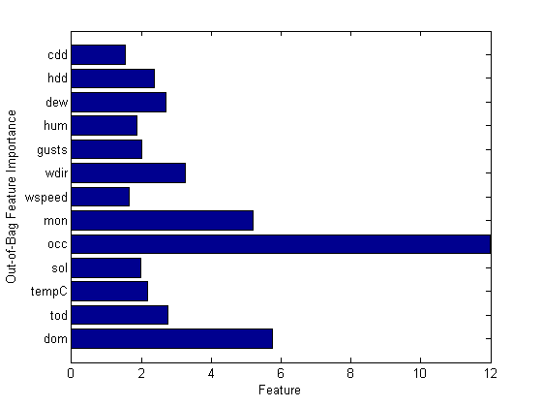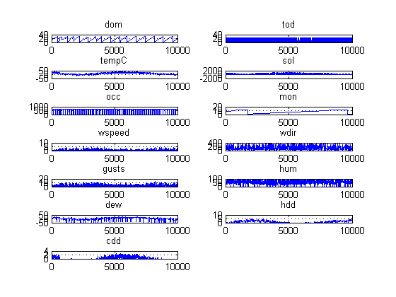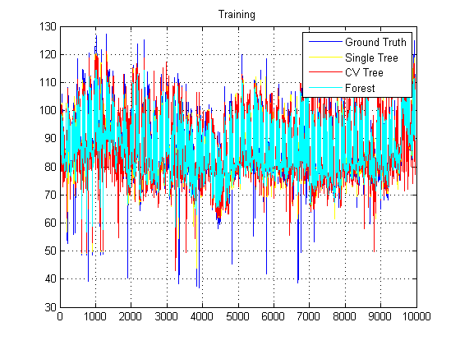

**Goddard Labs Interpolated Old Data**

Learning Regression Tree...

Elapsed time is 0.321599 seconds.

Training RMSE(W): 1.91, R2: 0.877, RMSE/peak: 0.0300, NRMSD: 4.13

Learning a cross validated tree...

Elapsed time is 2.690959 seconds.

Cross Validated Training RMSE(W): 2.77, R2: 0.741, RMSE/peak 0.0435, NRMSD: 5.99

Learning a Random Forest...

Elapsed time is 91.571902 seconds.

Random Forests Training RMSE(W): 2.17, R2: 0.841, RMSE/peak 0.0341, NRMSD: 4.70

Testing RMSE(W): 7.39, R2: 0.000, RMSE/peak: 0.1104, NRMSD: 16.55

Cross Validated Testing RMSE(W): 7.21, R2: 0.000, RMSE/peak 0.1077, NRMSD: 16.14

RF (Testing) RMSE(W): 6.92, R2: 0.000, RMSE/peak 0.1033, NRMSD: 15.49

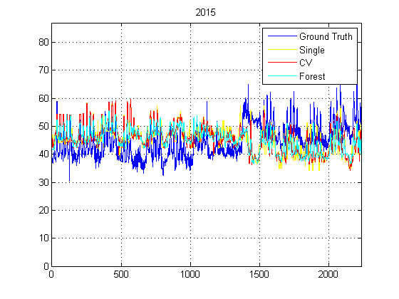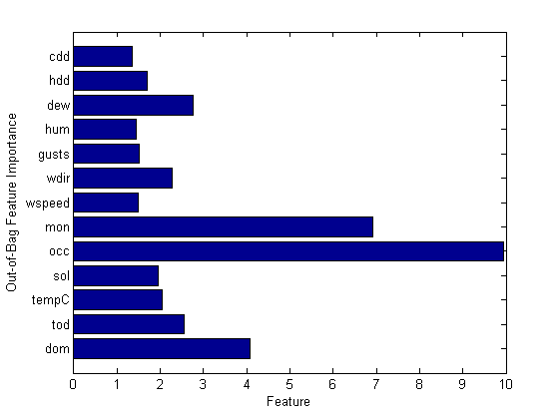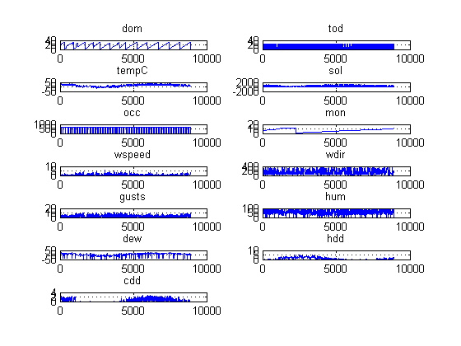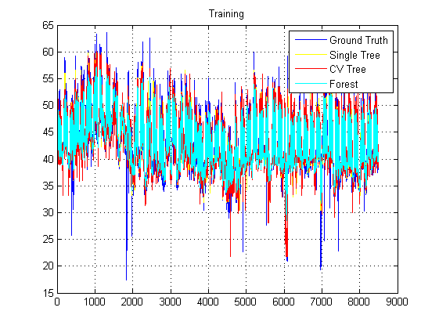

**Goddard Labs Interpolated New Data**

Learning Regression Tree...

Elapsed time is 0.392941 seconds.

Training RMSE(W): 4.32, R2: 0.852, RMSE/peak: 0.0340, NRMSD: 4.77

Learning a cross validated tree...

Elapsed time is 3.279146 seconds.

Cross Validated Training RMSE(W): 6.60, R2: 0.655, RMSE/peak 0.0518, NRMSD: 7.28

Learning a Random Forest...

Elapsed time is 110.209461 seconds.

Random Forests Training RMSE(W): 4.87, R2: 0.812, RMSE/peak 0.0383, NRMSD: 5.38

Testing RMSE(W): 15.43, R2: 0.000, RMSE/peak: 0.1104, NRMSD: 16.06

Cross Validated Testing RMSE(W): 14.57, R2: 0.000, RMSE/peak 0.1043, NRMSD: 15.17

RF (Testing) RMSE(W): 13.61, R2: 0.000, RMSE/peak 0.0974, NRMSD: 14.17

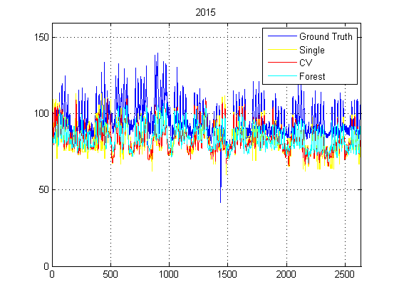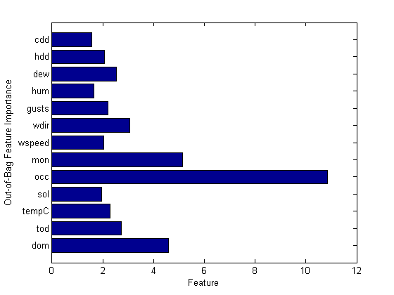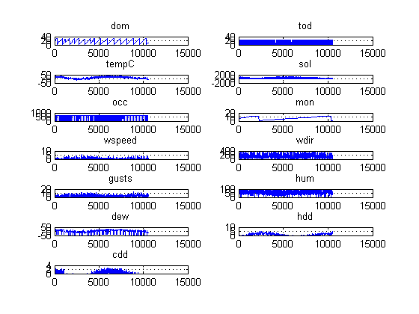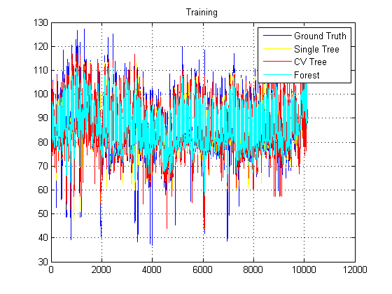

**Goddard Labs Not interpolated Old Data**

Learning Regression Tree...

Elapsed time is 0.499853 seconds.

Training RMSE(W): 1.40, R2: 0.925, RMSE/peak: 0.0220, NRMSD: 3.03

Learning a cross validated tree...

Elapsed time is 4.418836 seconds.

Cross Validated Training RMSE(W): 2.79, R2: 0.702, RMSE/peak 0.0439, NRMSD: 6.04

Learning a Random Forest...

Elapsed time is 146.696954 seconds.

Random Forests Training RMSE(W): 1.51, R2: 0.913, RMSE/peak 0.0237, NRMSD: 3.26

Testing RMSE(W): 7.05, R2: 0.000, RMSE/peak: 0.1053, NRMSD: 15.73

Cross Validated Testing RMSE(W): 6.87, R2: 0.000, RMSE/peak 0.1026, NRMSD: 15.33

RF (Testing) RMSE(W): 6.69, R2: 0.000, RMSE/peak 0.1000, NRMSD: 14.93

